Exercise 6

Design a online book store website using CSS (Cascading Style Sheets) which includes

the following:

1) Use different font, styles:

In the style definition you define how each selector should work (font, color etc.).

Then, in the body of yourpages, you refer to these selectors to activate the styles.  
  
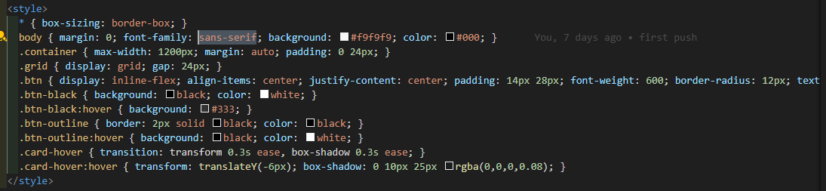  


2) Set a background image for both the page and

single elements on the page.You can define the

background image for the page like this:

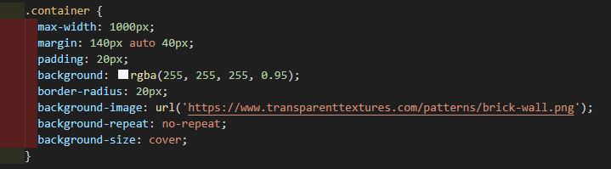

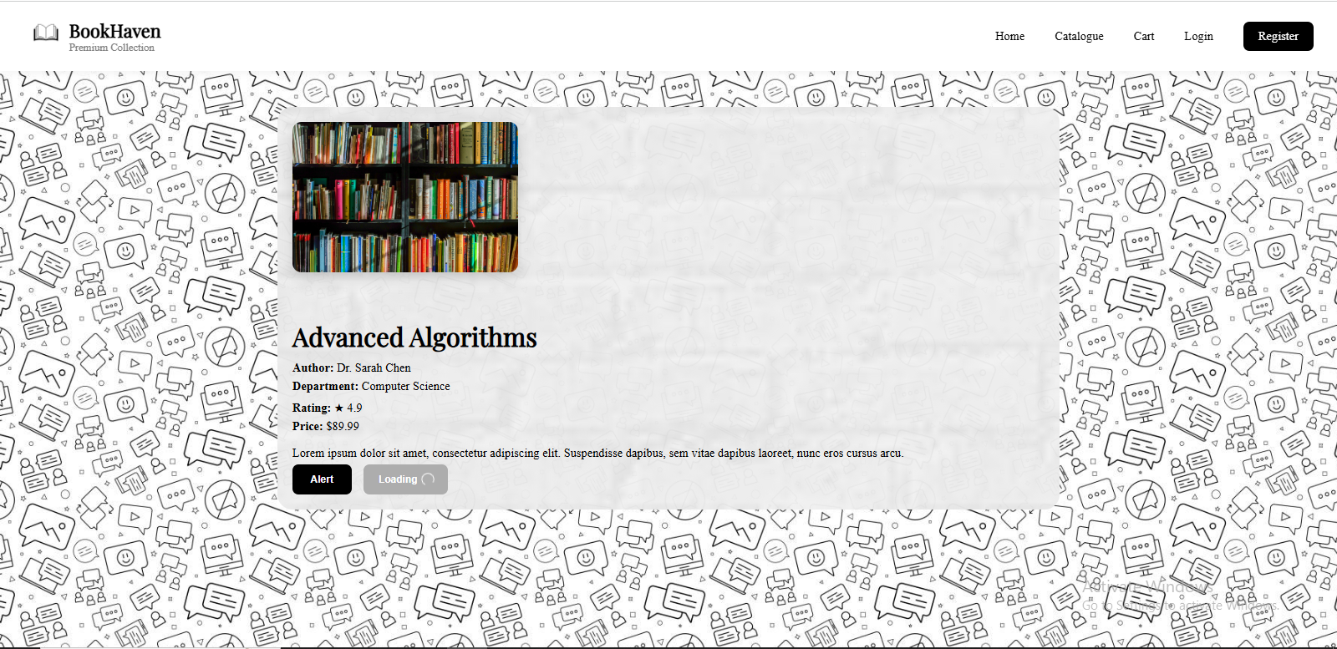

3) Control the repetition of the image with the background-repeat property.

As background-repeat: repeat Tiles the image until the entire page is filled, just like an

ordinary background image in plain HTML.

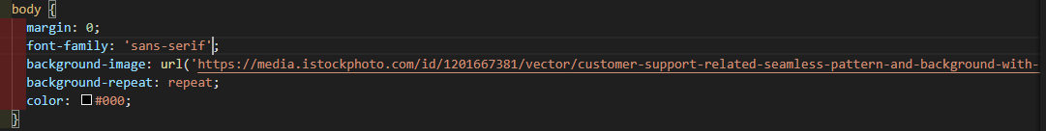



4) Define styles for links as

A:link

A:visited

A:active

A:hover

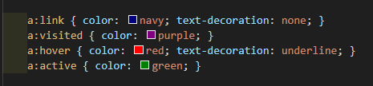



5) Design a Horizontal Dropdown menu inside Navigation bar by using CSS.

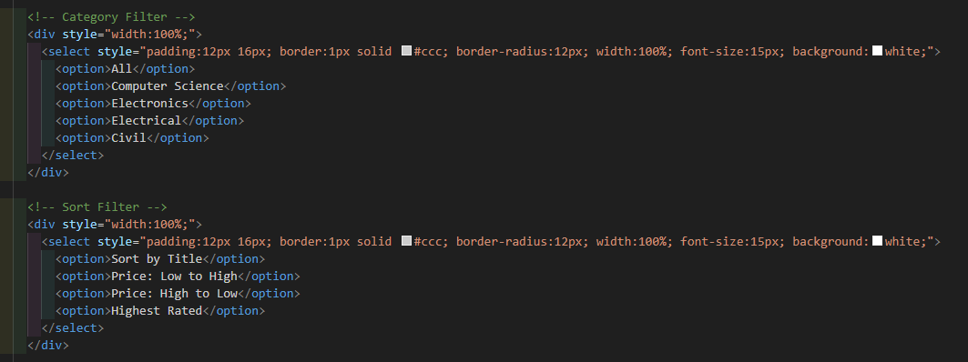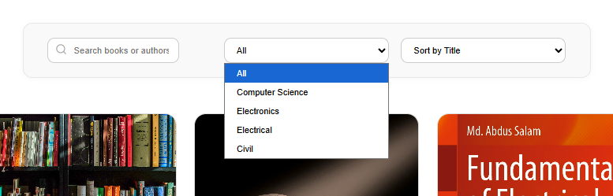

6) Design a Alert Buttons in CSS.



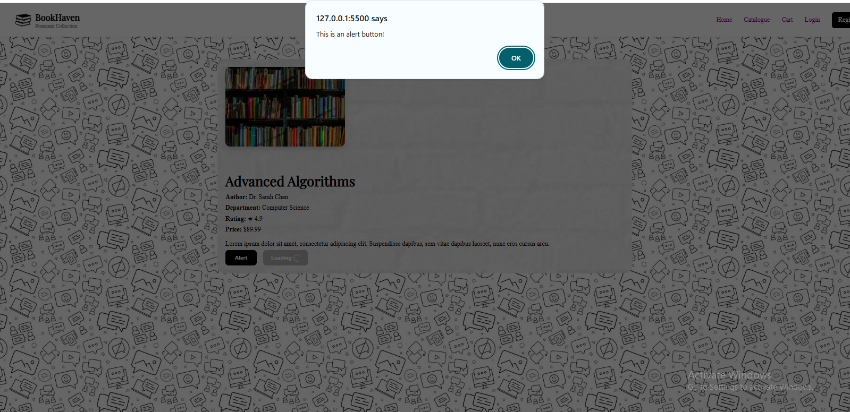

7) Design a Loading Buttons in CSS





Add the video:  
